Reflections from the Field
May 21, 2026

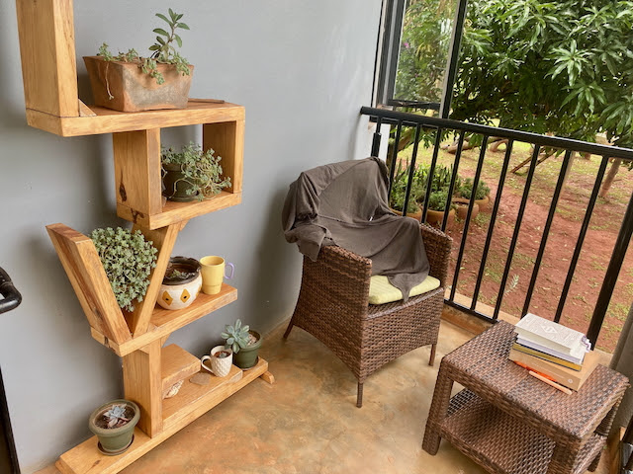

Most mornings I try to wake a little earlier than the kids and come out to the solace of my front porch. Quiet reflection, prayer, and Bible time are the grounding factors to my day. I’ve become so accustomed to it that I often miss it in busier seasons or even mornings where I have to get up and go immediately. The porch seasons have changed. About a year and a half ago we lost our Nixie dog who had been with us over 10 years. Then in March we found out our remaining pooch, Nugget, was struggling with a hidden disease and we had to make the heartbreaking decision to let her rest. Both had been faithful companions for over a decade! My porch time took a hit. It wasn’t as cozy without them. About the same time in March my health took a hit too. I was hit with severe fatigue and debilitating headaches which seemed to snowball into excruciating migraines about half the time. Nothing seemed to be working and I was out of commission some days and back at life in full force the next. The cycle continued for several weeks. Life plodded forward but I felt somewhat removed from it. I couldn’t face the sun some days. I was tired beyond a better sleep schedule.
Being forced to step back, I reflected differently. First, I had to get well and get things in order so that I could once again participate in life like I so love doing. If you know me at all, you know I don’t put a toe into an endeavor but I tend to jump in with all my heart, soul, mind, and body! It has been hard to watch the world go by some days and feel like I am not able to be a part. These last several weeks I have been in full recovery mode—some days better and some worse. There are a few things that have helped immensely and I want to share them here, with you—friends, families, friends like family, and churches like family as well!

I had to step back by force due to being unwell, but then I also stepped back with intention. How many times have I written or talked with any of you about needing rest and rejuvenation? We are so grateful for so many opportunities to serve and be a blessing that I feel I’d lost track of my own well-being. Everything is harder with a migraine. But when it lifted each time, I looked at the triggers and how I got there. Bottom line: I was going too hard and too fast and neglecting my own wellness and limits. Serving at our church was at the top of this routine that was actually hurting me. Stressors and issues within church leadership and staff were mounting. I was picking up the slack of others and insistent that things could and would work. These are not the nice newsletter stories you all probably hope for, but they are reality! I feel compelled to share because you may be able to find yourself in them too!

I had to step back and not give quite so much. A team player, I had to let individuals take the brunt of their own actions or inactions. This wasn’t easy for me. I had to shift from a mindset of “doing all I can do” to “capability does not equal compulsion.” I had to let the balls drop and quit juggling so much. I stepped back; my health returned. Now, we have all taken a rest from what sometimes is draining where it is supposed to be encouraging. We’ve taken action to restore better order. I never did like juggling anyway! ;-)

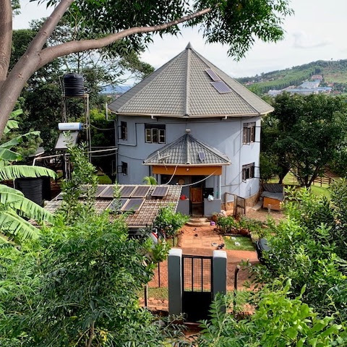
Home sweet home, as taken from a tree in the garden by Peter

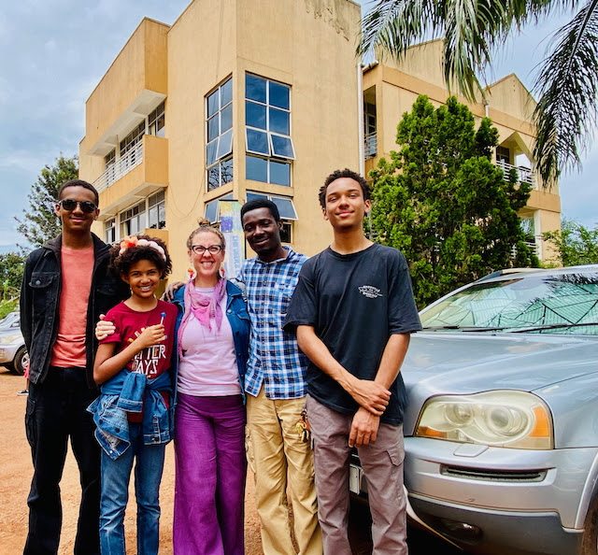
The family at church together!

Our entire family serves our city church just 20 minutes away, and it has been a beautiful and also challenging experience. Another area we serve is our local community. The ministry focuses on being good neighbors to those all around us. Sometimes that looks like a beautiful message of hope wrapped up in the Christmas baskets delivered! Sometimes it looks like mediation with village and family concerns. It mostly looks like checking in on the forgotten and forlorn folks in our greater family, which is our community of Wairaka. But there are struggles here too. Peter always says, “Helping people is the hardest job!” There are strongholds and limiting beliefs in this particular area. Unemployment is high, but work ethic is low. People want to eat and have money, but they don’t want to work or lend a helping hand.

You may remember a story we told early on during our Covid food relief outreach, where an elder received food help and asked who on earth we are! “In this village, we don’t even throw each other a bone, let alone good gifts like these!” He wept as he thanked us, wowed by the good deed! But was he motivated to love by a love we shared? This exposed the heart of this little community (not all of Uganda). Is love shared really multiplied? Does the help in a great time of need spur on their desire to love, or does it encourage a poverty mentality that is so common in the area?
The answer is a mixed bag! The issues we hear about, see happening, and help find solutions for continue. But there is a peace in the giving. There is a peace in the conflict management (whether at church or in the community). This peace that passes all understanding is at the center of wherever we reach out with God’s love. There are many beautiful parts of this culture where we live (by the way, this is not Peter’s tribe or tongue here either). We often share the highlights with a little of the struggles. Here today I just lay it out as we experience it on the daily. Solutions don’t always come easy. But there is a command so clear: “A new commandment I give to you, that you love one another; just as I have loved you, you also are to love one another. By this all people will know that you are my disciples, if you love one another.” —Jesus (from John 13:34-35) The peace we feel is a direct result of the command we follow. “Peace I leave with you; my peace I give to you. Not as the world gives to me, I give to you. Let not your hearts be troubled, neither let them be afraid.” —Jesus (from John 14:27).

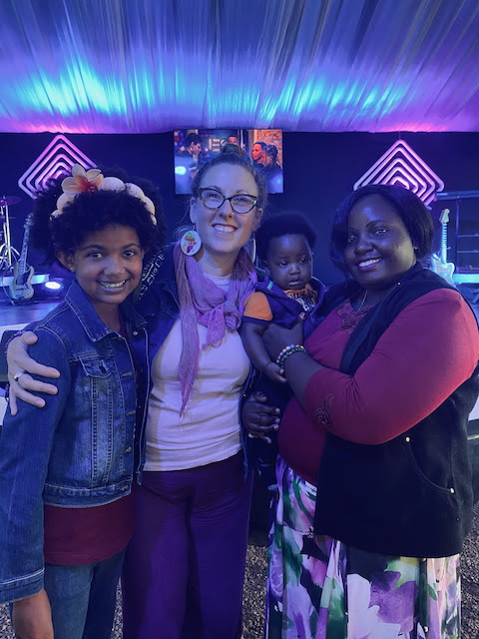
A sweet friend from church forged through prayers for her baby she now holds!

In order to enter his PEACE we have to enter his LOVE and vice versa. Our actions for Christ never replace our relationship with him. This season, we have purposely stepped back for a reorientation. Where things felt so frustrating and messy, we pulled away enough to rest from it. Aiden reminded us last night that Jesus left the crowds and sought solitude. We have too. Yet, the work has continued; just like Jesus was followed and called upon during his rest. But our approach feels renewed and our hope is restored.
The command is simple: Love one another.
The underlying principle behind it is always: Peace.
The troubles will come. The winds will blow. We pivot, we pray, we press on.
“I have said these things to you, that in me you may have peace. In the world you will have troubles. But take heart; I have overcome the world.” —Jesus (John 16:33)


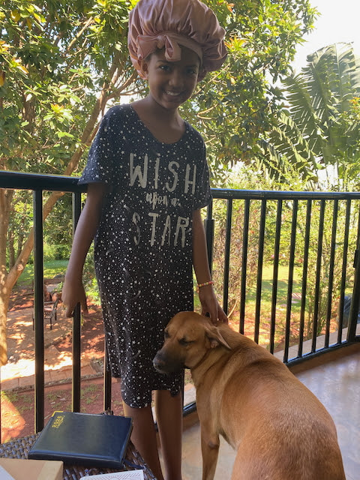

I’m back on my porch lately. Two new rescue dogs have found their way into our home and hearts. Maggie, a two-year-old hand-me-down dog, has found her forever home with us just a few weeks ago. Where she had endured years of trauma (it showed), she now is safe and thriving. Milo is just 3 months old and a turbocharged little tough guy. He’s growing with us and bringing lots of joy too. As I enjoy my morning time this day, I couldn’t help but notice the Eastern Plantain Eaters (aka turacos, pictures below by Levi)) above us in the trees. We’ve watched many generations of them nest, live, and eat in the luscious trees and gardens right in our own yard. Lately, they are doing something new. They have always made nests in a very old tree with brittle branches. Sometimes the nests go down with the branches. This season, they are building in the avocado tree on the other side of the house. That side has less wind, and the tree itself is steady and sturdy.

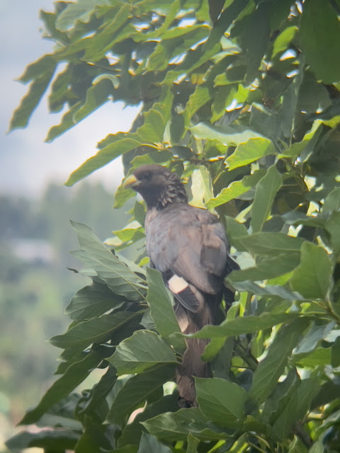
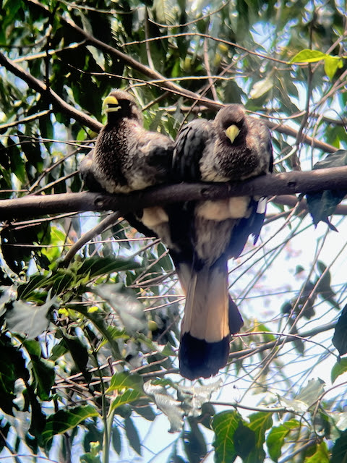

As I step out daily, I’m soaking in the PEACE of God first! I am then more equipped to receive the LOVE of God for myself, which beautifully overflows to the community around us. I also take inspiration from the turacos in the trees. They aren’t giving up; they are moving slightly to a less resistant area. They are rebuilding. They do so using the old tree for nest materials and food while moving to a more stable one. They’ve clearly learned from past experiences how to move forward in this season. It’s a joy to take in their process.
We too will take lessons from previous seasons to restore new places we chose to extend love and peace. It won’t all go perfectly; storms blow, strongholds and customs dig in their heels, and conflict is part of the process. A nest blown to the ground is not a reason to stop. All hopes are not dashed. Challenges are part of the growth process.

Suddenly, I feel right where God has placed me. I feel centered and grounded. We are purposed and planned. A rest and a reset are often needed and not taken. My health has been a symptom of a bigger need to Sabbath better. This season has taken us down, but it hasn’t taken us out. Can you relate?
Are you resting in the PEACE and LOVE of God? It is there in ample supply.
Are you staying in a situation that is full of strife and resistance in your own strength or pressing into a bigger picture that you are beautifully woven into?
As I share my reflections, I think of you! You have stood with us through thick and thin, changing seasons and changing focuses of outreach and ministry. You have been a part of the old seasons and new seasons. You have been a part of the rebuilding! You have been a steadfast and faithful branch in many seasons, making up a supportive tree we can count on. This too is God’s love displayed! You are a part of the beautiful plan God has called us all to—loving others well. Thank you! You mean so much to us!
“And the peace of God, which surpasses all understanding, will guard your hearts and your minds in Christ Jesus.” (Philippians 4:7)

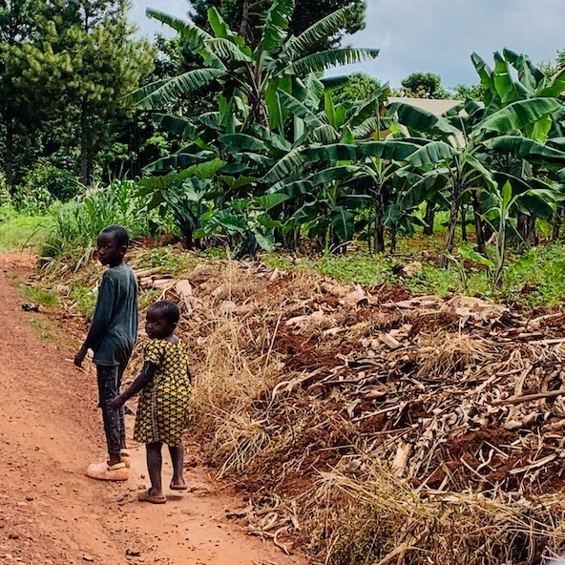
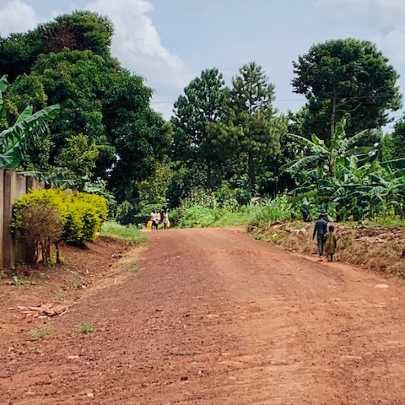

Much love to you from the Walugembe Family!
Peter and Kate (Levi, Aiden and Eliana) Walugembe

Link to Pioneers for Giving Options

Checks can be written to “Pioneers”
10123 William Carey Dr., Orlando, FL, 32832 for
Peter and Kate Walugembe
Acc. 111654

